STATISTICAL INFERENCE

**INDIAN STARTUP FUNDING ECOSYSTEM**horizontal line

# 

# 

# 



# 

# 

# COURSE CODE: MAT4103

# SUBMITTED BY:

ARUNDHUTI CHAKRABORTY 22MSD7046

HARSHITA BAJAJ 22MSD7013

SHRITAMA SENGUPTA 22MSD7032

**SUBMITTED TO:**

PROF. SANTANU MANDAL

## 

## 

## 

## TABLE OF CONTENT

ABSTRACT

INTRODUCTION

METHODOLOGY

DISCUSSION

STARTUP FUNDING

FUNDING PATTERN ANALYSIS

GOVERNMENT INITIATIVES

UNICORNS

ANALYZING FACTORS AFFECTING UNICORNS

PREDICTION OF VALUATION OF STARTUPS

PROJECT SUMMARY

CONCLUSION

REFERENCES

## 

## 

## 

## 

## 

## 

## ABSTRACT

India has entered the golden age of entrepreneurship, currently holding the third-largest market share for startups worldwide. Funding is the backbone for launching and sustaining any startup company. This leads to higher earnings and a better spot on the market (market valuation). This research analyzes funding patterns in the Indian startup market, concentrating on geography, industries that are most appealing to investors, and funding sources.

One of the key findings from our research is that the Startup India Initiative has a role to play in the valuation of unicorns which forms the cream layer of the startups. Taking the unicorns as a sample we try to draw relationships between the company's valuation and the funding they receive. In all, we have tried to amalgamate the funding ecosystem of the startups with their valuation in the near future.

## 

## 

## 

## 

## INTRODUCTION

Indian Startup culture is on a rise, to say the least. The previous decade and a half have seen substantial changes in India's entrepreneurial ecosystem, from the formation of new startups to worldwide investor interest, as well as advancements in infrastructure and legislation. India currently has the third largest number of startups in the world with 88,923 (as on Jan 2023) registered startups across 656 districts of the country. India recently crossed the landmark of 100 unicorns in Sept 2022 only behind the USA. The high rate of entrepreneurial activity in India indicates positive outcomes for the country; including an increased rate of value creation and economic growth[1](https://www.researchgate.net/publication/247885912_The_FreeMarket_Innovation_Machine_Analyzing_the_Growth_Miracle_of_Capitalism)( (Baumol 2002; Leff 1979; Wennekers and Thurik 1999), and employment opportunities(Glaeser et al 2015). Due to this, there is a shift in the mindset of job seekers, who want jobs in the rising environment of startups.

India's greatest asset and defining characteristic is its diversity. Start-ups are the carriers of this diversity. The range includes anything from simple delivery services to payment options and taxi services. Working in India's diverse markets and varied cultures offers a wealth of experience. Start-ups from India can therefore readily interact with nations throughout the world. Dreams are now not only local but also global.

The number of unicorns(companies with a valuation of more than 1 Billion) has tripled in the last three years in spite of COVID-19, which has caused significant socioeconomic misery throughout the world, yet it is at this time that the resilient Indian entrepreneurs have worked tirelessly to not only contribute to the economy but also to COVID-19 relief efforts.[2](https://ischoolconnect.com/blog/a-guide-to-unicorn-start-ups-in-india) 'It's raining unicorns,' was the year 2021's mantra, with 44 unicorns being poured into the environment.

The government on its part has incorporated many policies to further promote the growth of startups. The flagship initiative is the "Startup India Scheme," which provides exemptions from Income Tax and Money Gains Tax for qualifying startups and a credit guarantee scheme, incubation facilities, a simpler exit procedure for failing startups, legal help, rapid tracking of patent applications, and a website to eliminate information asymmetry.

Funding also played a huge role in boosting the rapid growth of startups. The success of a startup is highly dependent on having the right amount of capital in place. Startups are funded from time to time which aids in growing operations, creating new services, and products, and hiring more staff. Startups commonly obtain investment from seed, angel, venture capital, and private equity.

( David, Gopalan, and Ramachandran 2020) Funding not only helps with the financial elements of the business, but it also provides legitimacy to the startup eventually leading to creating greater employability. Considering funding as the primary factor, an overall overview of the region, industry, and investment type-based analysis has been showcased along with the overall effect of government policies on the ecosystem.

## METHODOLOGY

Data has been collected from government and other legitimate websites which comprise data on various Indian startups, their location, current valuation, funding, and the founding year. Analysis has been carried out on sample data which comprises data on Indian unicorns. Regression analysis is implemented to create a model which fits the valuation of unicorns based on their funding and further, the valuation has been predicted for the entire population. Among various statistical tools, ANOVA has been implemented on categorical features to study the impact of government policies on numerical categories.

Visualization tools like tableau is been used to present the EDA(Extrapolatory Data Analysis) in the form of dashboards.

## DISCUSSION

**WHAT ARE STARTUPS?**

"I see startups, technology, and innovation as exciting and effective instruments for India's transformation": Narendra Modi, Honourable Prime Minister

There is no precise hard and fast definition of what a startup is, the accepted characteristics of a “startup” span its age, the scale of operations, and mode of funding. Like as stated under Startup India, a startup is defined as a company that has been registered for less than five years and has an annual turnover of less than Rs.25 crore in any fiscal year. It is an organization that aims to innovate, create, implement, or commercialize new goods and services based on technology or intellectual property.

**WHY STARTUPS?**

Startups are the backbone of new India, as such Jan 16 is declared National Startup Day. The startup ecosystem has taken center stage in India's economic activities. In this era of a global pandemic, the pace and scope at which India's youth are founding start-ups is a testimonial to their strong will and perseverance. Startups have played a significant part in transforming India from the world's IT, services, and business process outsourcing powerhouse to a key R&D center for international corporations. Today, entrepreneurship is not looked down upon but rather encouraged.

Startups also to an extent try to solve the huge problem of unemployment. The number of jobs created by startups has seen a gradual increase in the last decade or so. Next-gen technological solutions like AI, IoT, Blockchain, and Machine learning are used to address deep and complex challenges across sectors which eventually take economic activity and growth to the next level.

## 

## 

## STARTUP FUNDING

Startup funding is basically the capital raised by Startups to support their business venture. For any business to thrive it needs capital, it's the most exciting as well as a crucial aspect of an entrepreneur's journey. Assume you are the founder of a startup. Your company is maturing, and you're eager to hire additional personnel to convert your product prototype into a reality. But you need funding to make it happen.

Funding can come in many forms, the type we will be talking about in this research is an outside investment by which they raise money through funding rounds. Angel, venture, and private equity deals often include equity in the company. The concept is that once the firm starts making money, the investors will be willing to get their money back.

Companies seeking outside capital often start with a seed round before progressing to Series A, B, and beyond rounds. However, before any rounds can commence, the firm must be valued. A valuation takes into account the startup's maturity, management, market size, track record, profit, and risk, which might influence who is interested in the firm and how much fresh funding it can bring in.

Startups can commence a financing round after the valuation is complete. The pace and method differ from firm to company; some entrepreneurs spend months looking for investors, while others conclude a round in a couple of weeks.

Some startups move slowly through each funding round, while others build capital much faster.

The major rounds of funding an entrepreneur seek at each stage of their development are:

1. **Private equity**: As stated earlier most of the funding startups receive is in exchange for a share(equity) in their company. This stage of funding can be raised at any stage but is mostly raised in the early or idea stage when founders seek funds for developing prototypes of products/services.
2. **Seed/Angel Funding**: This funding assists a business in financing its initial phases, such as product research, product launch, marketing to a target audience, and audience building. Consider this stage to be the "seed" that allows the rest of the firm to develop and thrive. A founder would be unable to employ a team or test their concept in the market without it. Individual investors and VCs focused on seed funding to further support startups until it generates revenue forms the cluster of investors around this funding.
3. **Series A**: When a company uses its seed capital to grow a product and a client base, it may be ready for a Series A fundraising round. This cash is frequently used to increase a company's product offerings, attract additional consumers, and build a long-term growth strategy.As a result, businesses undergoing this financing round attract investors from traditional private equity firms.
4. **Series B and beyond**: The focus of Series B and beyond rounds is on business development and how to attain the next stage of growth. The funds received in this round will be used to sustain an existing client base by adding additional employees and expanding sales, marketing, technology development, and customer support. Additionally, the already successful startups require more capital to help produce new products, buy other firms, grow into new industries, or employ an extraordinary leadership team. The funding is intended to assist the scale of the company's operations so that it may develop as soon as possible — and because investing is less risky in this round, additional investors join in. The major portion of investors here is constituted of

Institutional investors, venture capital funds, and the corporate venture arm of large corporations.

1. **Debt Funding:** Debt funding for startups refers to the various methods by which a new firm can be given cash to help it grow through the startup stage. This is critical for new and developing businesses, as is acquiring the appropriate quantity of the finance. Debt funding includes, but is not limited to: loans,revenue-based financing, and MRR Line. Loans can be an ideal way to get business off the ground if the loan is taken on favorable terms. Revenue-based financing involves a business agreeing to share a percentage of its future revenue. MRR lines are available to SaaS (Software as a Service) companies with low churn and a good credit profile. Mostly personal guarantee has to be offered before a startup can be considered for an MRR line.

## FUNDING PATTERN ANALYSIS

*What water is to a plant, funding is to startups.*

**TOP FUNDED CITIES AND STATES -**

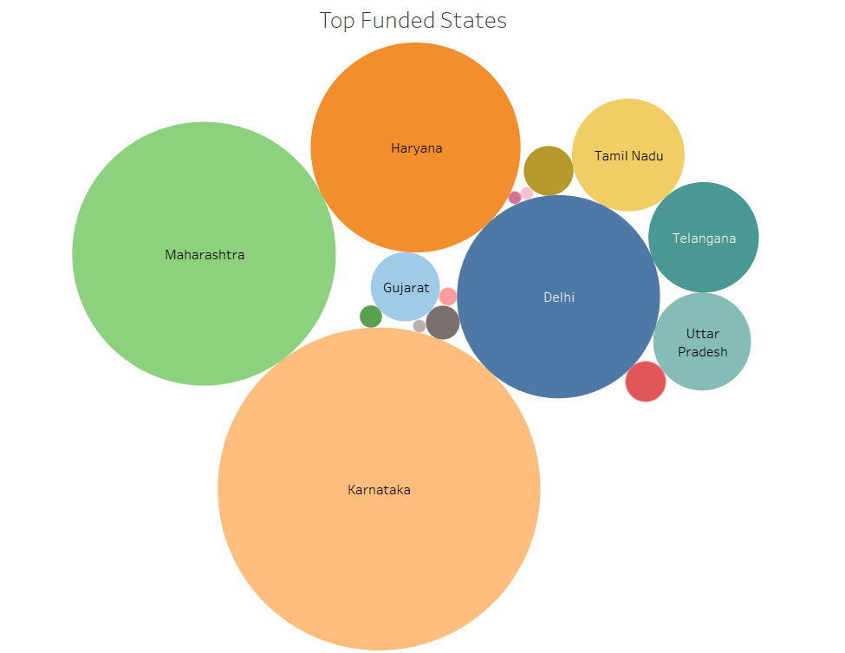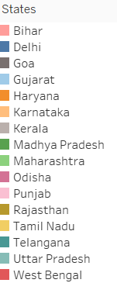

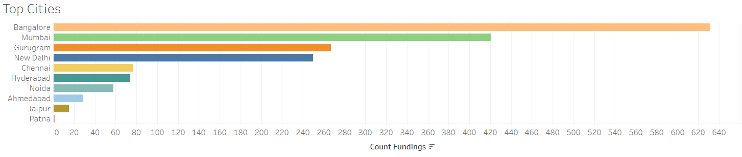

When it comes to cities for startups, Bengaluru, the Silicon Valley of India, takes the top spot. It has a reputation for having the best environment for commerce and digitization. The biggest IT businesses in the country are based there, including Infosys, Wipro, Mphasis, and many others. It has also served as a cradle for a number of businesses, including Flipkart, Ola, InMobi, and Quikr, and so on. The startup ecosystem has been receiving an overwhelmingly positive reaction from investors for some years now, including seed-stage investment, and has been increasing pace.

Young entrepreneurs are receiving encouragement from this growth to develop revolutionary concepts, which is driving India's entrepreneurial environment forward.

Despite being positive, this increase is not the same in all Indian states. When it comes to the expansion of the startup ecosystem as a whole and the number of startups, cities like Bangalore, Delhi, Gurugram, and Noida are at the forefront.

A major reason why states like Karnataka, Maharashtra, and Delhi are doing well is that their state governments have established more policies and initiatives to boost startups as compared to other states. For example, to encourage businesses in industries including biotechnology, tourism, and animation, the Karnataka government adopted a startup strategy and established several funds totaling more than Rs 300 crore in 2015.

Other states such as Rajasthan, Punjab and Madhya Pradesh, West Bengal, and their corresponding cities have started gaining funding in recent years due to the Startup India Initiative. However, for them to grow, more industrialization and support from the state government is required.

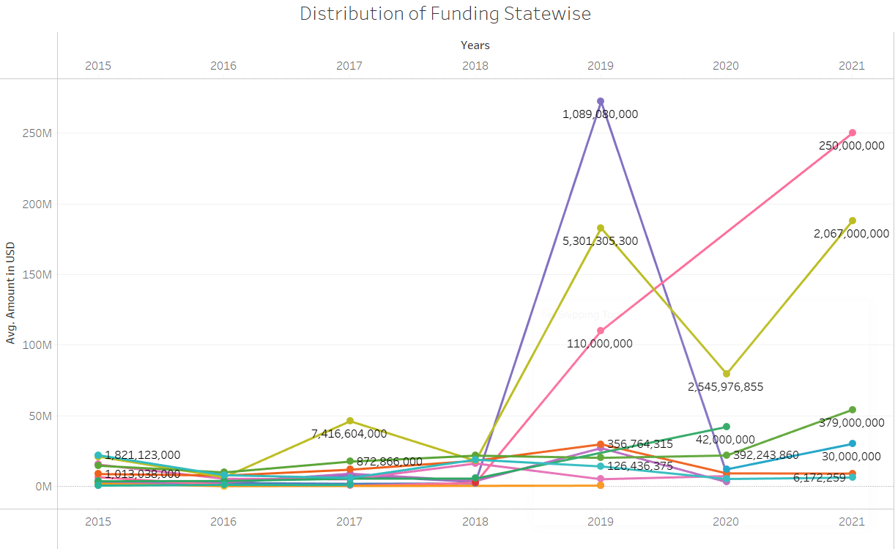

An interesting observation that can be made in the above plot is that states gained large funding when the pandemic sets in, during 2019. This is because internet-based, remote technologies and contact less transactions gained popularity, and startups in these areas boomed due to large demand for their services. Online food delivery, e-commerce, and health-tech are receiving large funding due to the rapidly increasing demand for their services. Funding in these industries is discussed further in the upcoming section.

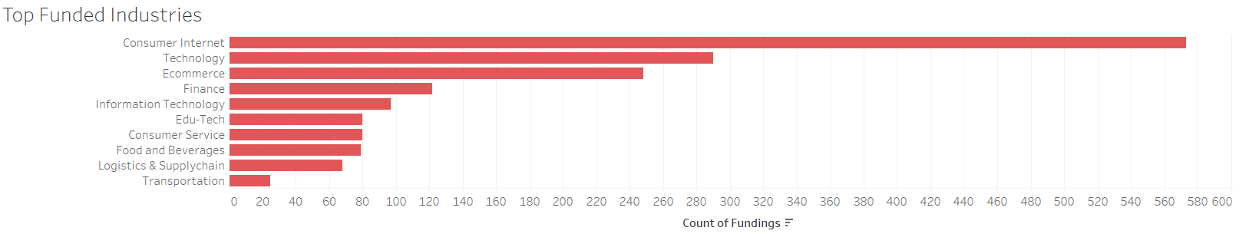**INDUSTRY WISE -**

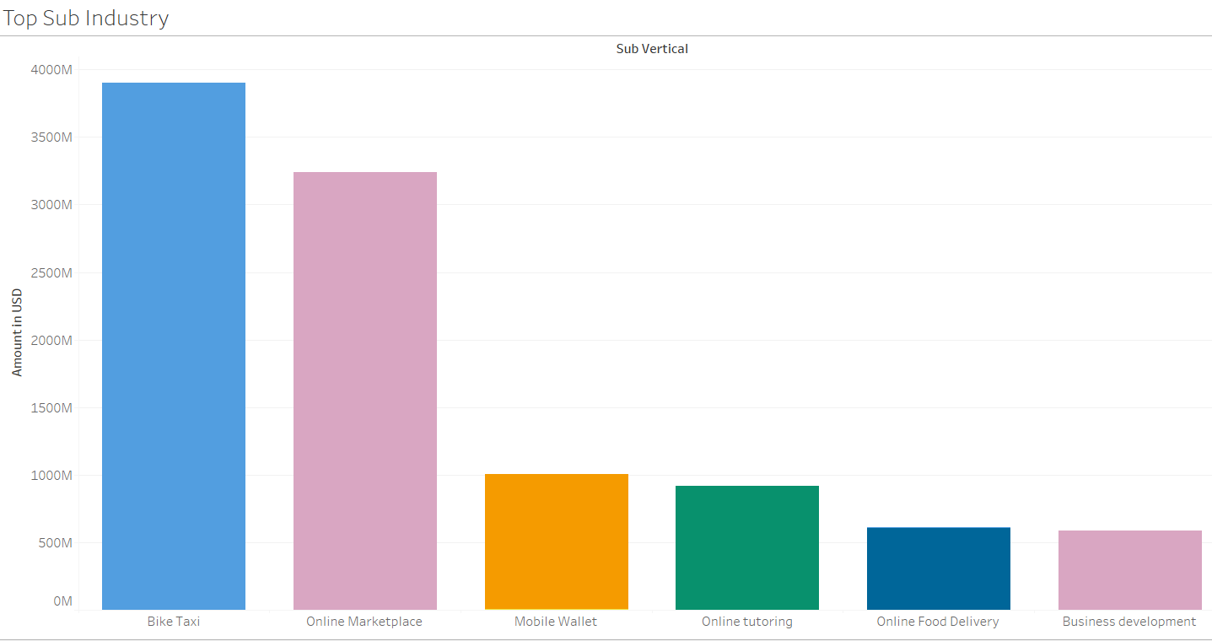

Consumer Internet -

Consumer internet and e-commerce companies have emerged as the most preferred industry

segments across start-ups. The Indian consumer internet sector has grown significantly due to the rising digital infrastructure, a boom in internet subscribers, increased investor interest, and the government’s initiatives to promote digital adoption. Also, the rise of the global pandemic has led people to rely more on internet-based services.

Information Technology -

By introducing them to ERP management and SaaS technology, enterprise IT has been transforming businesses in India and increasing their efficiency, productivity, and profitability. Many small and medium-sized businesses have used SaaS and other cutting-edge strategies to successfully streamline their processes. They are enabling B2B services to grow, integrating technology in all sectors like finance, healthcare, education, agriculture, etc. Investors are valuing technology-based companies as they are rapidly growing in the market due to their high scalability and automated management systems.

Fintech -

Many notable fintech businesses have emerged in recent years, disrupting and innovating this conservative industry in ways that were desperately needed. The government's determination to turn India into a cashless economy is one of the most visible changes to the fintech industry that have occurred in recent years. Numerous cashless payment technologies, including internet banking, mobile-driven POS, and digital wallets, have been introduced as a result, successfully reshaping the financial industry. Fintech has long been the most popular investment option for VCs and ordinary investors when it comes to financing.

Food and Delivery Services -

Zomato, Ubereats (now owned by Zomato), and Swiggy are some of the top Indian food delivery firms, and Big Basket, Amazon, and Grofers are some of the largest names in grocery delivery, to mention a few. For almost five years, food and grocery delivery services have been among the most popular startup industries in India. For the fiscal year 2018–19, food delivery giant Zomato made a staggering $206 million in sales.

Logistics and delivery services are growing rapidly as consumers purchase everything online from food, grocery, medicines, to daily commodities. Investors recognise this as an ever growing market and are funing the startups which promise better logistics solutions.

Edu-Tech -

The major edtech startups in India, including BYJU'S, Unacademy, Upgrad, Vedantu, and others, saw a sharp increase in their numbers. Additionally, it meant more money from investors looking to join the edtech trend.

The Indian EdTech market was estimated to be worth US$ 750 million in 2020 and is anticipated to grow to US$ 4 billion. The need for personalization in the EdTech industry and the growing demand for non-academic courses from tier II and III cities are the main drivers of this rise. From the estimated market value of $4 billion, US$ 1.5 billion will go into 1-12 standard, after-school fundamentals, and pre-preparatory courses.

According to the Annual Status of Education Report (ASER) 2020, smartphone ownership among families with students attending public schools went from 30% in 2018 to 56% in 2020, while smartphone ownership among families with students attending private schools increased from 50% to 74%.

The National Education Policy 2020 emphasized the value of utilizing technology in educational solutions and backed the development of educational content in regional languages, designating it as a high priority.

Transportation-

In India, a highly fragmented taxi service business that has historically been dominated by independent operators and cruising cabs is being upended by a new generation of mobility entrepreneurs employing technology.

The opportunity for venture capitalists is in the seemingly endless demand for local transportation, according to investors who are pouring money into this quickly expanding industry. According to Avnish Bajaj, MD of Matrix Partners India, "the cab and car rental business in India is one of the large remaining travel verticals still to be organised."

Healthcare -

The epidemic has brought into sharp focus the necessity of a robust, technologically-driven response for improved healthcare delivery. In fields like telemedicine, remote patient monitoring, and preventive healthcare, technology is being adopted more frequently.

In order to capitalize on the health opportunity across segments like nutrition management, diagnostic and management, lifestyle monitoring, health checkups, and mental and physical wellness, more than 40 preventive healthcare technology ("HealthTech") start-ups have raised roughly $1 billion in funding over the last three years, according to the release.

Agriculture -

Agri-tech companies are gaining attention from investors due to their innovative solutions to farming and harvesting calamities. Remote areas where farming takes place now have access to the internet and are exposed to e-marketplace technology. Entrepreneurs have large scope for building startups in this unexplored sector. However, the government needs to boost innovative ideas and technology by assigning funds and creating farmer and investor-friendly policies.

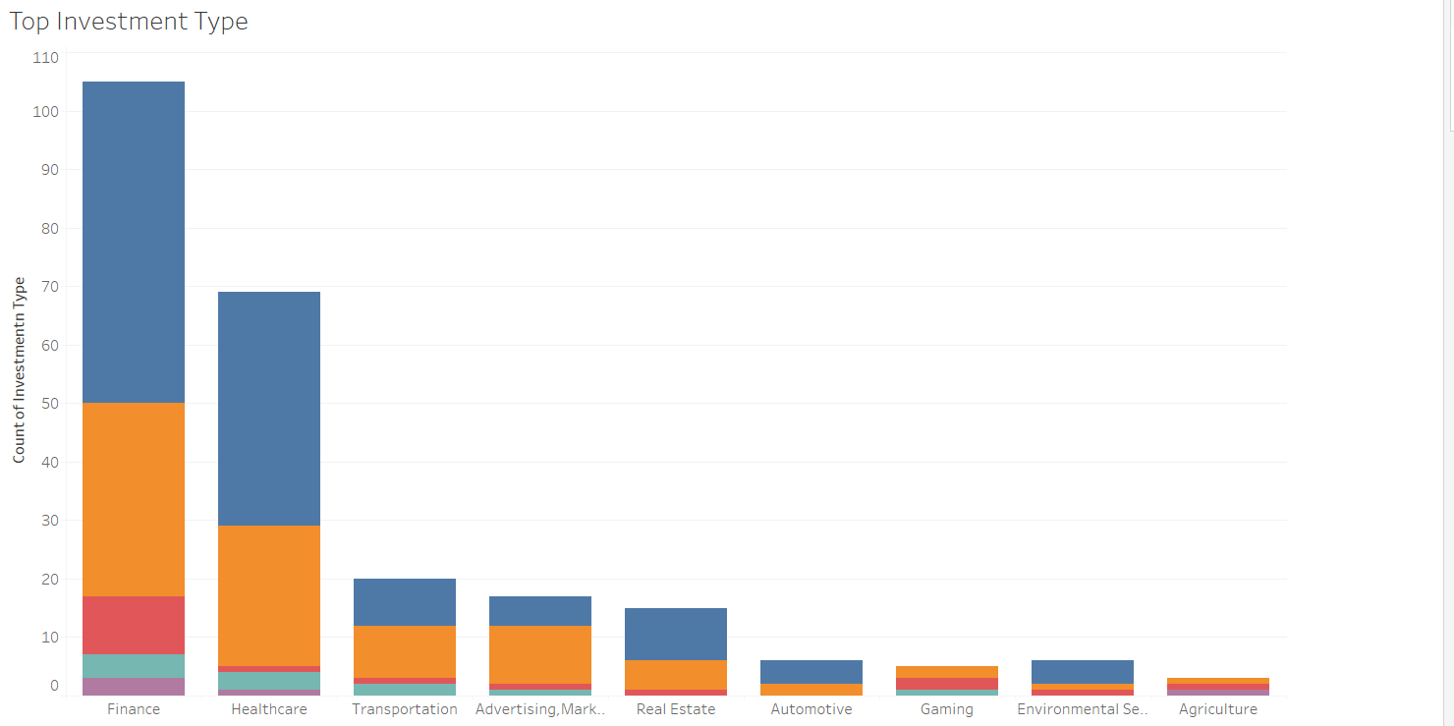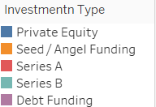

**INVESTMENT TYPE TREND-**

Private Equity -

Private equity has grown in popularity in recent years, attracting millions of dollars for the simple reason of high growth potential. According to a circular issued on September 13, it is expected to grow further, with the Government of India showing support by forming an expert panel to suggest ways to scale up VC/PE investments.

According to a report by IVCA and consulting firm EY, private equity and venture capital, funds will invest $77 Bn in Indian companies in 2021, representing a 62% increase year on year. While the actual number of transactions increased by 37% to 1,266.

The main reason for the growth of private equity is because of the gain the investor gets not only from the interest on the money but also from the percentage of shares he holds in the company, which is huge in the long run.

Angel Funding -

Startups in India are coming up with solutions and services which are disruptive and have huge potential for growth. Tools like cloud services, analytics, and interconnectivity via the internet are enabling founders to create such products and services which can quickly gain popularity and start generating revenue. This is why angel investors are staking their money on new and innovative startups.

## 

## 

## 

## 

## 

## 

## 

## 

## 

## 

## GOVERNMENT INITIATIVES

Government policies have been a key factor in determining the various attributes associated with startups. The startup culture gained momentum in the late 2000s, enormously gaining a leap since the mid of 2010, after the commencement of various schemes.

| Timeline | Government Policies | Aims And Targets |
| --- | --- | --- |
| 2009 | Invest India | To create an investment promotion and facilitation agency |
| 2013 | SEBI’s Alternative Investment Fund Regulations | For Angel Investors new norms are created, which helps in the funding in the initial stages |
| 2014 | Make in India | The Government of India's (GoI) flagship effort aims to make India a "global design and manufacturing" destination. |
| 2015 | Digital India | The Government of India's flagship program aims at extending e-governance in order to promote inclusive growth and turn India into a "digitally empowered society and knowledge economy." |
| 2016 | Startup India Initiative | The GoI's flagship project to accelerate the startup culture and create an ecosystem for innovation and entrepreneurship. 80,152 recognized startups |
| 2016 | SIDBI “Fund of Funds for Startups (FFS)” | INR 100 billion corpus (approximately $1.4 billion) contributing to the Alternate Investment funds (AIFs) for investing in startups |
| 2016 | Bharat Interface for Money (BHIM) and United Payment Interface | National Payments created a mobile payment app.  Corporation to facilitate the use of the United Payments Interface  Payments that are both smooth and confirmed |
| 2019 | Technology Incubation and Development of Entrepreneurs (TIDE) 2.0 | MeitY-sponsored program to encourage socially responsible tech entrepreneurship through incubators that assist ICT businesses that use new technologies (IoT, AI, blockchain, and so on). |
| 2020 | Atmanirbhar Bharat Scheme | Special economic and comprehensive package. that help to make the country and its citizens independent and self-reliant |

The Startup India Scheme is a government of India program aimed at creating jobs and income. The purpose of Startup India is to develop and innovate goods and services while also creating jobs in India. The advantages of the Startup India Scheme include job simplification, financial assistance, government tenders, and networking possibilities. On January 16, 2016, Prime Minister Narendra Modi inaugurated Startup India. This program makes it easier for newcomers to get started in order to encourage them. The government has put aside Rs.10,000 crore for four years (Rs.2500 crore each year) to invest in various companies. The government offers numerous financial incentives to entrepreneurs in order to promote them, and has created an application and an internet gateway to allow for registration from anywhere and at any time. The Insolvency and Bankruptcy Bill of 2015 makes it easier for startups to close down quickly. the Government of India also announced the establishment of a Fund of Funds for Startups (FFS) at the Small Industries Development Bank of India (SIDBI) with a capital of INR 100 billion to be awarded to alternative investment funds (AIFs). But FFS has regularly fallen short of its intended allocations in the four years afterward, both in terms of direct investments in startups (only INR 6.02 billion across 142 businesses) and in its allocation to AIFs.

After the initiation of Startup India, there has been a rise in both the number of startups as well the employability created by them. Even during the pandemic hit years there has been a gradual increase.

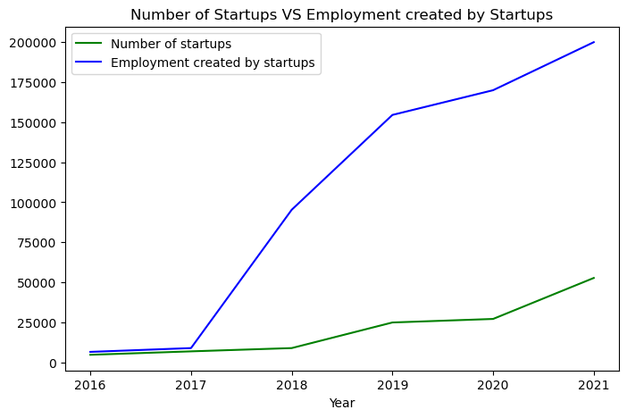

The data used in the graph above have been gathered by authors from data.gov along with other credible sources.

The graph above validates our claim, and not surprisingly the employment rate of the startups shows a steep increase, mainly from 2017.

The above graph shows an upward trend after the inception of Startup India, closing nearly 110M in the year 2021. Before that, it was in the range of 14M-9M.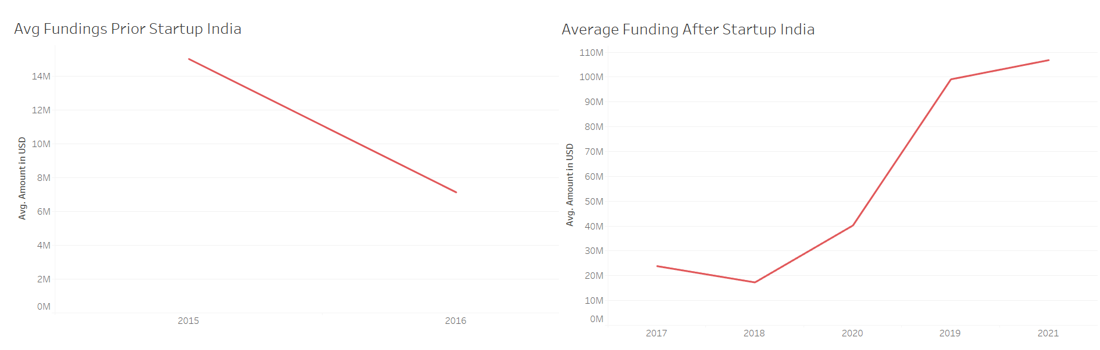

## 

## 

## 

## 

## 

## UNICORNS

A unicorn is a word used in the venture capital business to indicate a privately owned startup firm with a valuation of more than $1 billion. As of September 2022, India total has 107 unicorns, most of which attained the much-desired title in 2021. The unicorn rush in 2021 was caused by work from home during the pandemic, which fuelled the creation of digital enterprises in India and resulted in a lengthy unicorn list. Three things have primarily attracted investors: a growing digital payments infrastructure, a significant smartphone user base, and digital-first company strategies. Tech businesses that have become household names are contributing to India's unicorn boom, as smartphone penetration and digitalization of commerce in all aspects of life have expanded exponentially during the epidemic. 2022 (as on 7 September) saw 22 new unicorns added to the list, maintaining the trend. 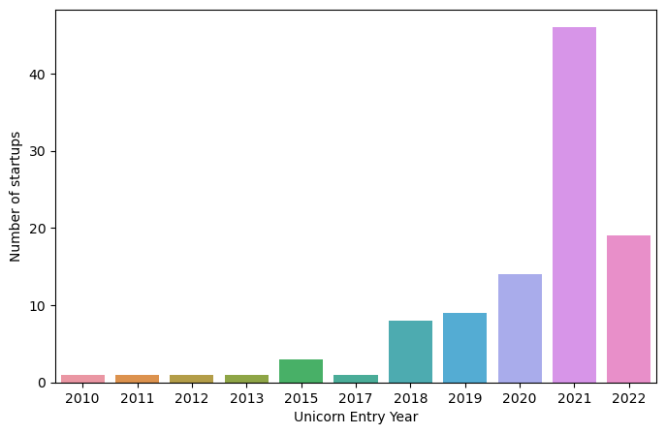

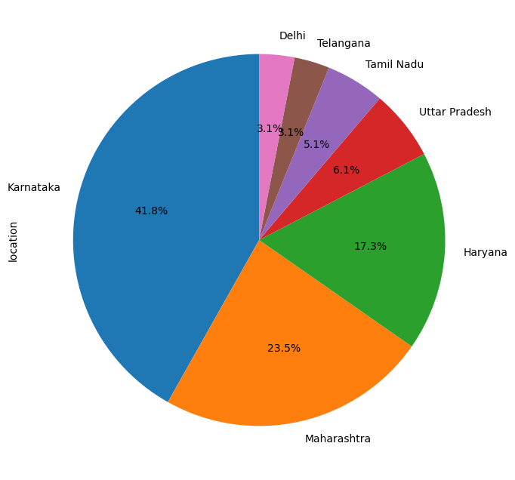

.

Not surprisingly, Karnataka takes the lead here, as Bangalore is called the startup hub of India proving an ecosystem for startups to thrive. Maharashtra takes second place due to the initiatives taken by the state ministry there promoting innovation. Haryana and Uttar Pradesh are mainly here due to Gurugram and Noida which along with Delhi, makes that region a startup hotspot too.

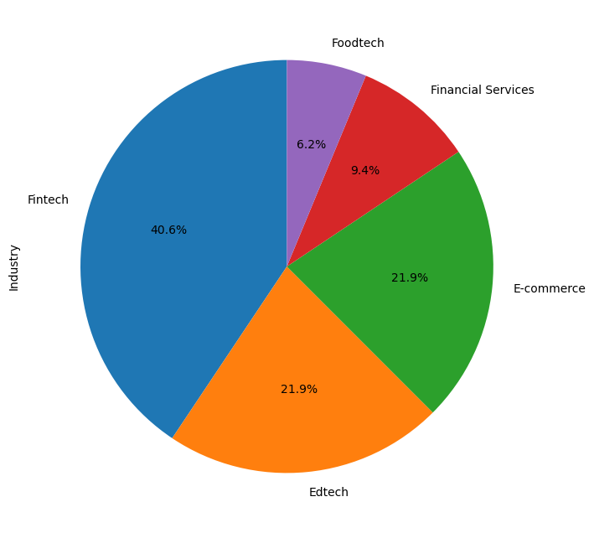

Tech Startups are at the forefront here too. Food tech and fintech make a major contribution to the unicorns list. E-commerce, Edtech, and the financial sector also are key industries.

## ANALYZING FACTORS AFFECTING UNICORNS

Unicorns form the cream layer of Startups. Taking them as samples we try to draw inferences upon the whole population.

Startup India as discussed earlier is the flagship initiative by GOI. We tried to see if startups that were founded before and after its initiation differ in their current valuation. Also, the effect of location is analyzed. Now, we have a dependent numerical variable upon which the effects of two independent categorical variables are to be determined, thus we use Two-Way ANOVA.

*ANOVA, or analysis of variance, is a powerful statistical technique used to demonstrate the difference between two or more means or components using significance tests. It also demonstrates how to make multiple comparisons of the means of different populations. The ANOVA test compares two types of variation, the variation between the sample means and the variation within each of the samples.*

*It can be determined by:*

*ANOVA test statistics: F = MSB/MSW,*

*Where F denotes the ANOVA coefficient.*

*MSB = Mean sum of squares calculated between groups.*

*MSW = Mean sum of squares across groups*

Here the null hypotheses to be tested on the sample are

| H01: There is no significant difference in average valuation between the unicorns founded pre-startup and post-startup India initiative. | HA1: There is a significant difference in average valuation between the unicorns founded pre-startup and post-startup India initiative. |
| --- | --- |
| H02: There is no significant difference in average valuation for unicorns in different regions in the country. | HA2:There is no significant difference in average valuation for unicorns in different regions in the country. |
| H03:The effect of one independent variable on current valuation does not depend on the effect of the other independent variable (a.k.a. no interaction effect). | HA3:The effect of one independent variable on average valuation does depend on the effect of the other independent variable (a.k.a. interaction effect). |

Here, the Type 2 error is more dangerous, thus we would increase the significance level to 0.10 from the standard 0.05 because we want to be cautious about failing to reject Ho when our null hypothesis is false, i.e. we don't want to infer that average valuation is same when it is not.

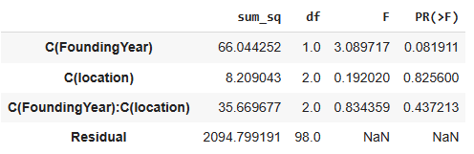

For the first assumption, we get the p-value to be smaller than 0.1, thus we have enough evidence to reject the null hypothesis and conclude that there is a significant difference in average valuation for unicorns founded pre-startup and post-startup India initiative.

For the second and third assumptions p-value is greater than 0.1 thus we fail to reject the null hypothesis and conclude that for the given sample of unicorns, the location does not have a significant effect on the average valuation of the beverage also, there is no interaction effect.

Thus, we can infer that the Startup India Scheme has a significant effect on the valuation for the population of all startups in the country. Now, why location which seems like a key factor does not have a significant effect on the current valuation?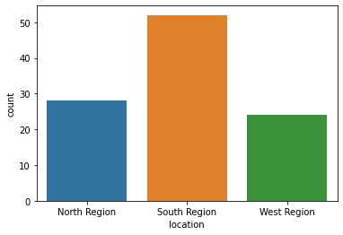

The count plot shows that there is a significant difference between the distribution of unicorns region-wise. The insignificance may be because of considering the location region-wise. Thus we can't exactly say that location does not have an effect on the valuation of the population of startups across the country, because the result may have differed vaguely if those restrictions were not present.

The data is collected from data.gov.in by the authors.

## PREDICTION OF VALUATION OF STARTUPS

For the sample of unicorns we have the individual funding received and their current valuation. Since here we have two numerical variables, a linear regression model will be best suited. The model is further utilized to predict the valuation of the entire population based on the funding they receive.

First, we see that valuation and funding have a high positive correlation.

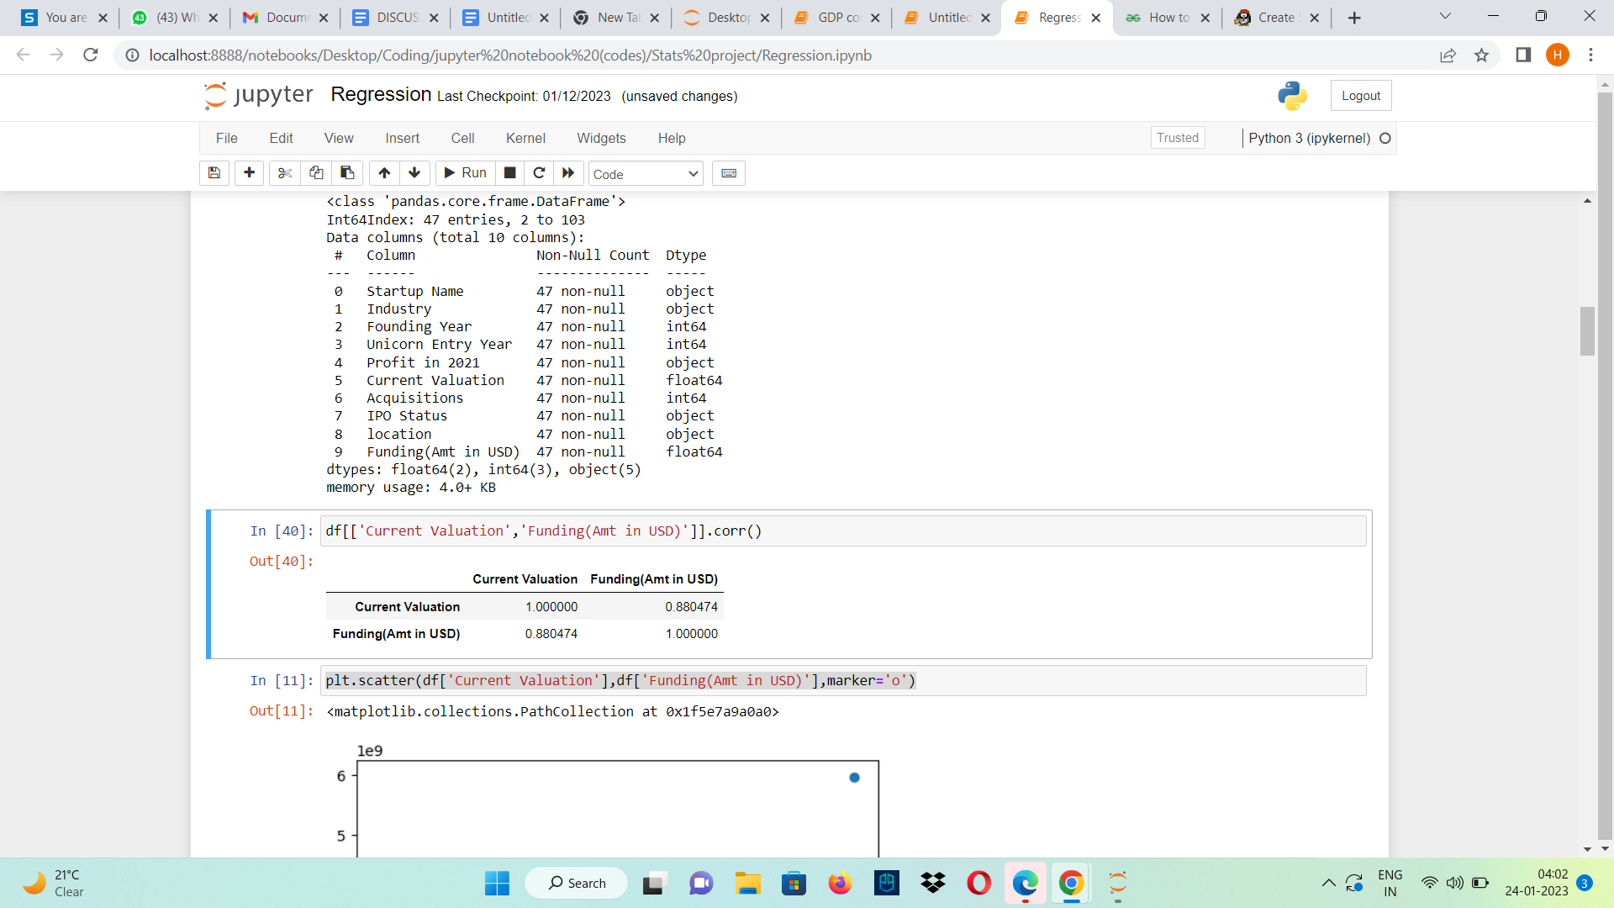

*The regression line for univariate regression*

*Y = b0 + b1*X*

*where,*

*Y = Current Valuation(dependent variable)*

*X =Funding( independent variable)*

*b1 = coefficient of regression*

*b0 = constant*

Estimating the model,

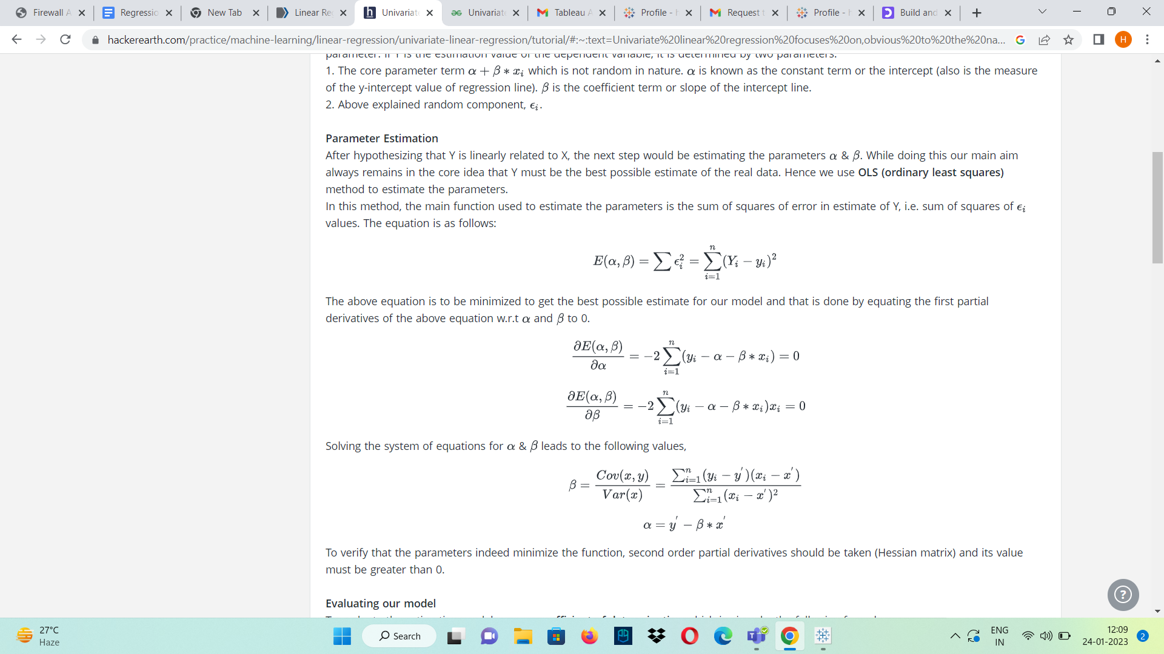

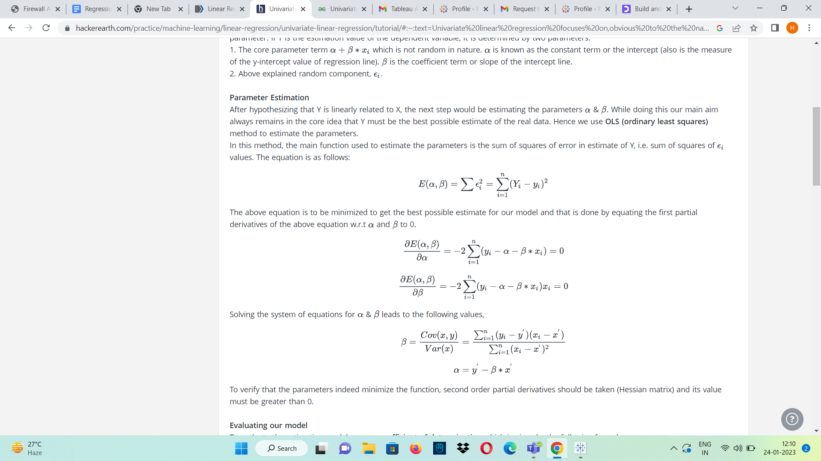

Evaluating our model,

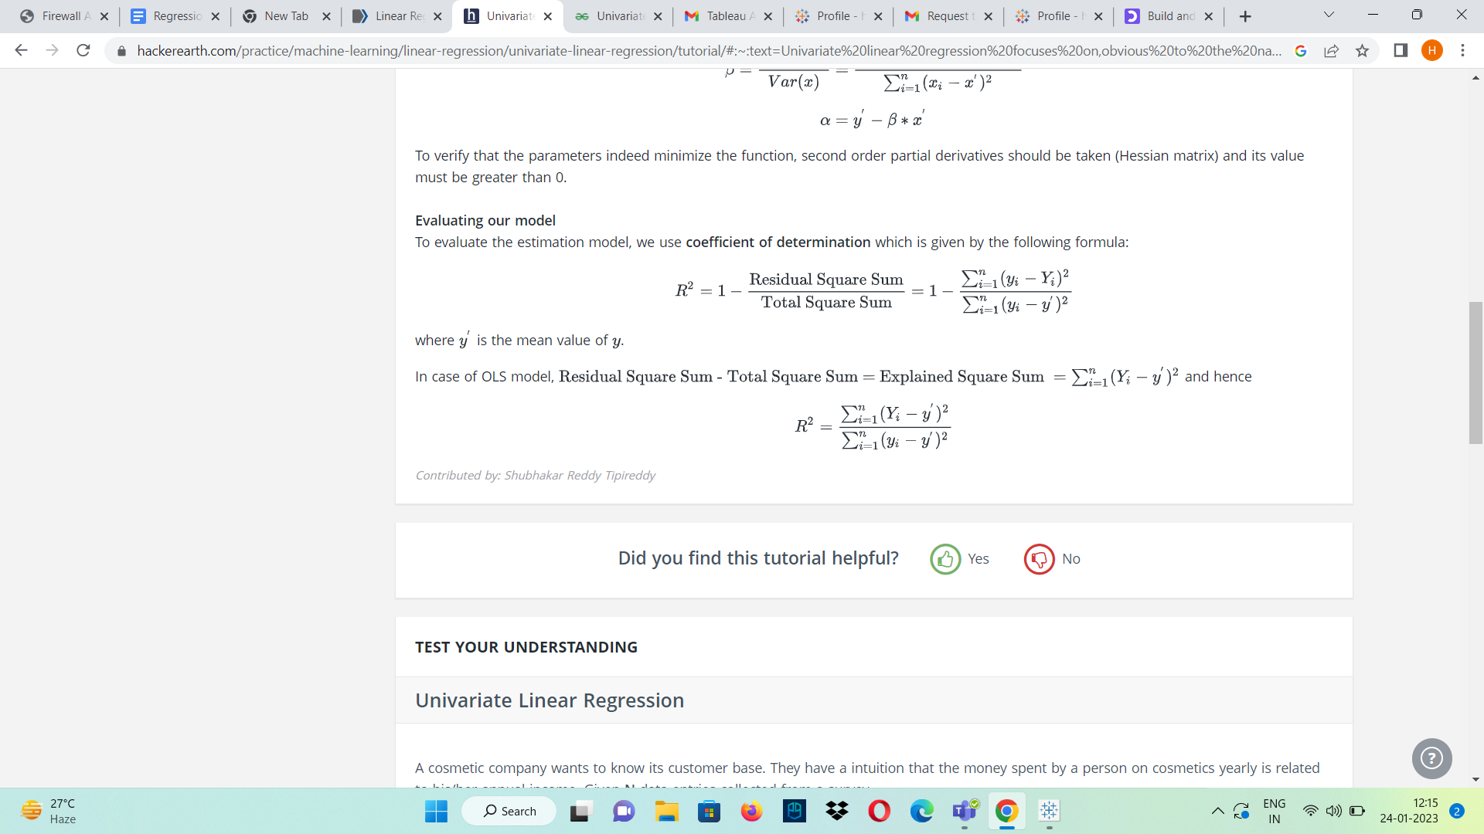

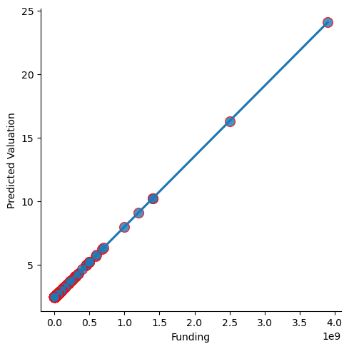

R^2 value of the best-fitted model is 0.83. It can be inferred that 83% of the variability observed in the valuation of the startups is explained well by the regression model. The best-fitted regression model is further used on the entire population data of Indian startups to determine their valuation based on their funding.

## PROJECT SUMMARY

Our project explores the startup ecosystem in India. In-depth analysis has been carried out using statistical techniques on unicorns taken as a sample, predictive models,s and visualization tools. First, we have carried out EDA (Exploratory Data Analysis) to explore the overall trends and patterns of India’s funding ecosystem. Statistical and predictive analysis has been applied to understand the key attributes that impact and are impacted by funding received over time by different startups.

Our analysis successfully shows how funding and the various government policies, the flagship being Startup India, play an important role in an Indian startup’s valuation in the near future.

## 

## CONCLUSION

India needs to focus on growing startups in vital sectors like environmental services and agriculture. There are many startups that are emerging in these fields but are not receiving the required funding from private investors as they are not customer-based services. However, innovation in these areas is vital and the government should look into implementing policies that offer funding to startups in the agriculture and environment sectors.

Startup India scheme plays a vital role in the valuation of startups, although it can be inferred that location does not have a significant effect on the valuation of a startup which can be possible due to insufficient data or categorization of the data. Further, It can be deduced that the funding raised and valuation of startups have gradually increased over the years. The estimated valuation illustrates a linear trend in the valuation suggesting that various startups can turn into unicorns in the coming years.

## REFERENCES

1. Padmanabhan, Arun. “Economic Survey 2022: At Least 14,000 New Startups Recognised in India, up 20 Times in Five Years.” *The Economic Times*, economictimes.indiatimes.com/tech/startups/economic-survey-2022-at-least-14000-new-startups-recognised-in-india/articleshow/89243366.cms. Accessed 25 Jan. 2023.
2. “About Startup India Initiative.” *ABOUT US*, www.startupindia.gov.in/content/sih/en/about-startup-india-initiative.html. Accessed 25 Jan. 2023.
3. “Startup Funding: What It Is, How It Works, and 5 Tips for Landing It.” *Startup Funding: What It Is, How It Works, & 5 Tips for Landing It*, 24 Jan. 2023, blog.hubspot.com/sales/how-startup-funding-works.
4. “Indian Unicorn Landscape - Startups, Growth, FDI, Investors.” *Indian Unicorn Landscape - Startups, Growth, FDI, Investors*, 7 Sept. 2022, [www.investindia.gov.in/indian-unicorn-landscape](http://www.investindia.gov.in/indian-unicorn-landscape).
5. “How Startups Contribute Towards Economic Growth in India? Read Here!” *OkCredit Blogs - Business Ideas, Tips, Government Schemes & More*, 2 Sept. 2020, okcredit.in/blog/startups-and-indian-economy.
6. “Startup Funding: What It Is, How It Works, and 5 Tips for Landing It.” *Startup Funding: What It Is, How It Works, & 5 Tips for Landing It*, 24 Jan. 2023, blog.hubspot.com/sales/how-startup-funding-works.
7. “Debt Funding for Startups | UpCounsel 2023.” *UpCounsel*, www.upcounsel.com/debt-funding-for-startups. Accessed 25 Jan. 2023.
8. “Startup India Seed Fund Scheme (SISFS) - Objectives and Guidelines | UPSC.” *BYJUS*, byjus.com/free-ias-prep/sisfs-startup-india-seed-fund-scheme. Accessed 25 Jan. 2023.
9. “Univariate Linear Regression Tutorials and Notes | Machine Learning | HackerEarth.” *HackerEarth*, www.hackerearth.com/practice/machine-learning/linear-regression/univariate-linear-regression/tutorial. Accessed 25 Jan. 2023.
10. “R-Squared.” *Corporate Finance Institute*, corporatefinanceinstitute.com/resources/data-science/r-squared. Accessed 25 Jan. 2023.
11. Subramaniam, N. (2023) *INC42's Indian Startup & Tech Predictions for 2023*, *Inc42 Media*. Available at: https://inc42.com/features/inc42-indian-startup-predictions-2023/ (Accessed: January 25, 2023).
12. Pourya.D(2023) *Startup fundraising: Fast and smooth*, *Startup Fundraising: Fast and Smooth*. Available at: https://www.startupheadway.com/ (Accessed: January 25, 2023).
13. Kenton, W. (2022) *Analysis of variance (ANOVA) explanation, formula, and applications*, *Investopedia*. Investopedia. Available at: https://www.investopedia.com/terms/a/anova.asp (Accessed: January 25, 2023).

## 